Ex.no:8 | MINI PROJECT – TOURISM DATA ANALYTICS

Aim:

To develop an interactive Tourism Data Analytics Dashboard using Power BI to analyze tourist information, destinations, travel purposes, spending patterns, satisfaction ratings, travel modes, booking channels, and repeat visitors.

Algorithm:
- Import the Tourism Dataset into Power BI and Tableau.
- Clean and transform the data using Power Query in Power BI and Data Source in Tableau.
- Check and correct the data types and remove unwanted or duplicate data.
- Create required calculated fields such as Spend per Traveller and Repeat Visitor Rate.
- Create the required data model and relationships in Power BI.
- Create required DAX measures and KPIs in Power BI.
- Create calculated fields and required measures in Tableau.
- Create charts for tourists, destinations, travel purposes, spending, satisfaction ratings, travel modes, booking channels, and repeat visitors.
- Add cards, KPIs, slicers, filters, and drill-throughs in Power BI.
- Add filters, dashboards, and interactive visualizations in Tableau.
- Design and format the dashboards in both Power BI and Tableau.
- Analyze the visualizations and identify important tourism insights.
- Present the final results through the interactive dashboards.
- End.

Architecture:

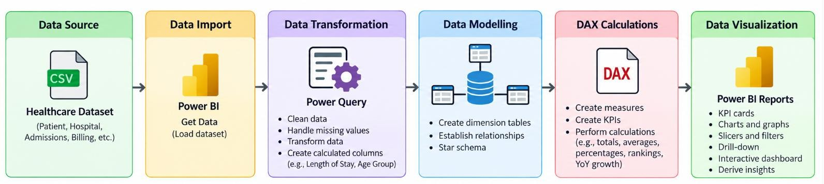

Program:

1. Python – Data Cleaning & Transformation

import pandas as pd

from sqlalchemy import create_engine, text

# Load dataset

df = pd.read_csv("Tourism_Analytics_Dataset.csv")

# Create a copy for processing

tourism = df.copy()

# Remove duplicate records

tourism.drop_duplicates(inplace=True)

# Handle missing values

tourism["country"] = tourism["country"].fillna("Unknown")

tourism["destination"] = tourism["destination"].fillna("Unknown")

tourism["travel_purpose"] = tourism["travel_purpose"].fillna("Unknown")

tourism["travel_mode"] = tourism["travel_mode"].fillna("Unknown")

tourism["booking_channel"] = tourism["booking_channel"].fillna("Unknown")

tourism["repeat_visitor"] = tourism["repeat_visitor"].fillna("No")

# Create Spend per Traveller

tourism["spend_per_traveller"] = (

tourism["total_spend"] / tourism["travellers"]

)

# Standardize column names

tourism.columns = (

tourism.columns

.str.lower()

.str.strip()

.str.replace(" ", "_")

)

# Display original and cleaned shape

print("Original Shape:", df.shape)

print("Cleaned Shape:", tourism.shape)

tourism.head()

2. PostgreSQL – Database and Data Loading

PostgreSQL:

CREATE DATABASE tourism_analytics;

Python/Jupyter:

username = "postgres"

password = "YOUR_POSTGRES_PASSWORD"

host = "localhost"

port = 5432

# Connect to PostgreSQL database

db_engine = create_engine(

f"postgresql+psycopg2://{username}:{password}@{host}:{port}/tourism_analytics"

)

# Load cleaned data into PostgreSQL

tourism.to_sql(

"tourism_data",

con=db_engine,

if_exists="replace",

index=False

)

print("Data loaded successfully into PostgreSQL.")

Verify:

pd.read_sql(

"SELECT COUNT(*) AS total_rows FROM tourism_data",

db_engine

)

3. Power BI – DAX Measures

Total Tourists

Total Tourists = COUNTROWS('public tourism_data')

Total Travellers

Total Travellers = SUM('public tourism_data'[travellers])

Total Spend

Total Spend = SUM('public tourism_data'[total_spend])

Average Satisfaction

Average Satisfaction =

AVERAGE('public tourism_data'[satisfaction_rating])

Average Stay

Average Stay =

AVERAGE('public tourism_data'[stay_nights])

Repeat Visitors

Repeat Visitors =

CALCULATE(

COUNTROWS('public tourism_data'),

'public tourism_data'[repeat_visitor] = "Yes"

)

Repeat Visitor Rate

Repeat Visitor Rate =

DIVIDE(

[Repeat Visitors],

[Total Tourists]

)

Spend per Traveller

Spend per Traveller =

DIVIDE(

[Total Spend],

[Total Travellers]

)

4. Tableau – Calculated Fields

Total Tourists

COUNT([Tourist Id])

Total Travellers

SUM([Travellers])

Total Spend

SUM([Total Spend])

Average Satisfaction

AVG([Satisfaction Rating])

Average Stay

AVG([Stay Nights])

Repeat Visitors

SUM(

IF [Repeat Visitor] = "Yes" THEN 1

ELSE 0

END

)

Repeat Visitor Rate

SUM(

IF [Repeat Visitor] = "Yes" THEN 1

ELSE 0

END

)

/

COUNT([Tourist Id])

Spend per Traveller

SUM([Total Spend]) / SUM([Travellers])

.4. Tableau Dashboard
Created visuals in tableau in separate sheets and created a dashboard

Output:

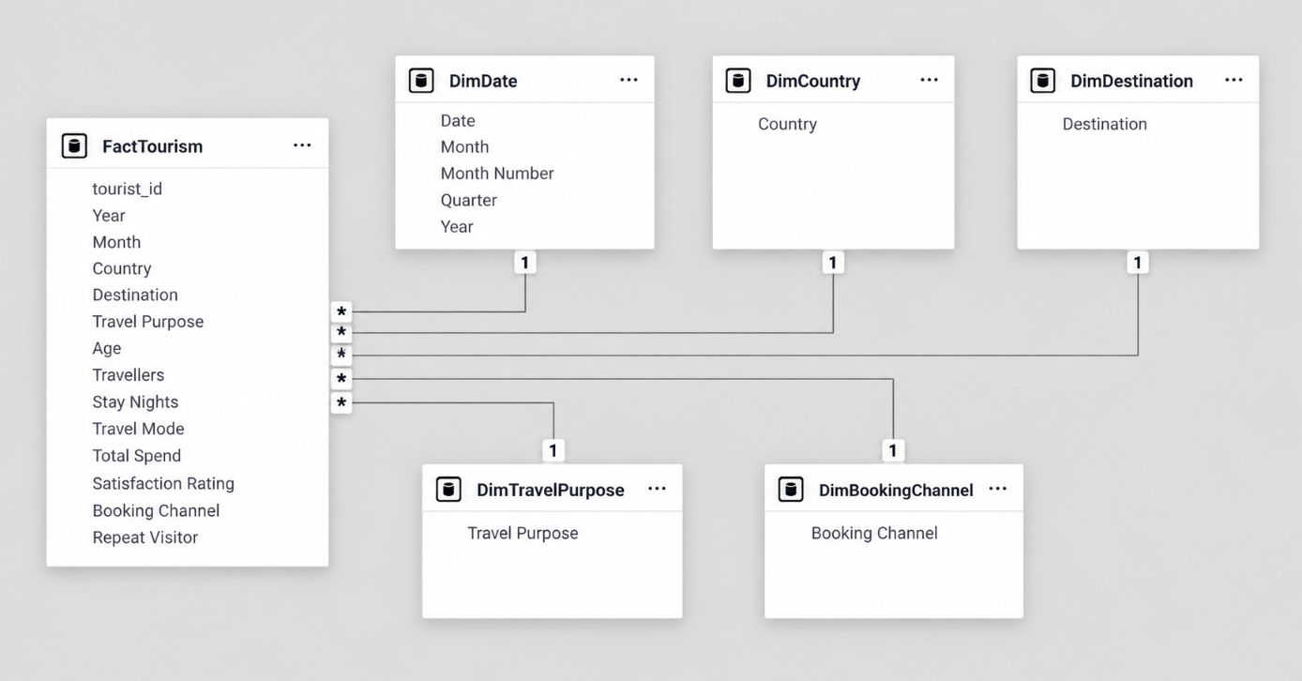

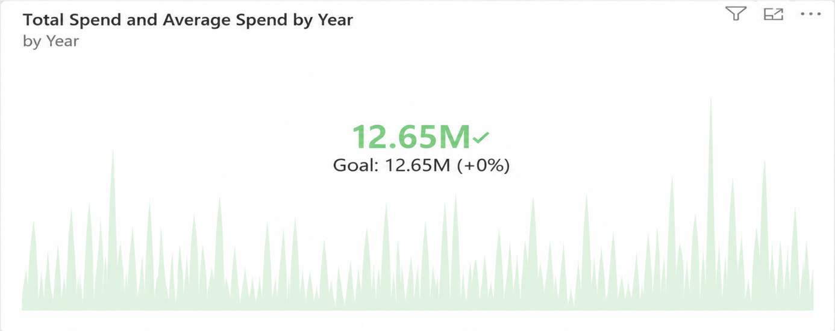

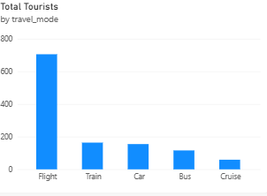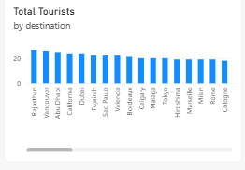

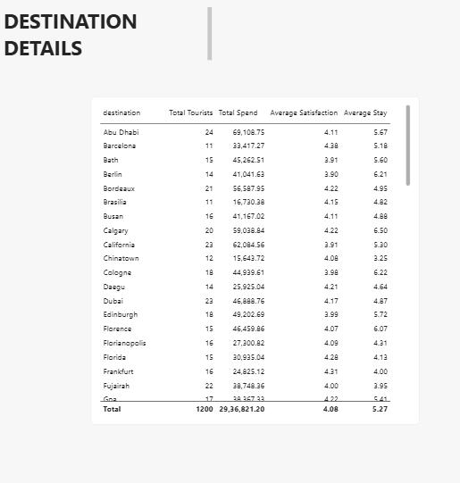

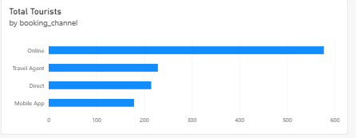
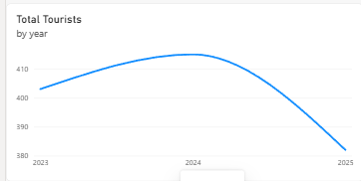

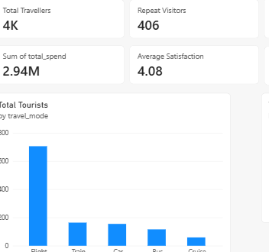
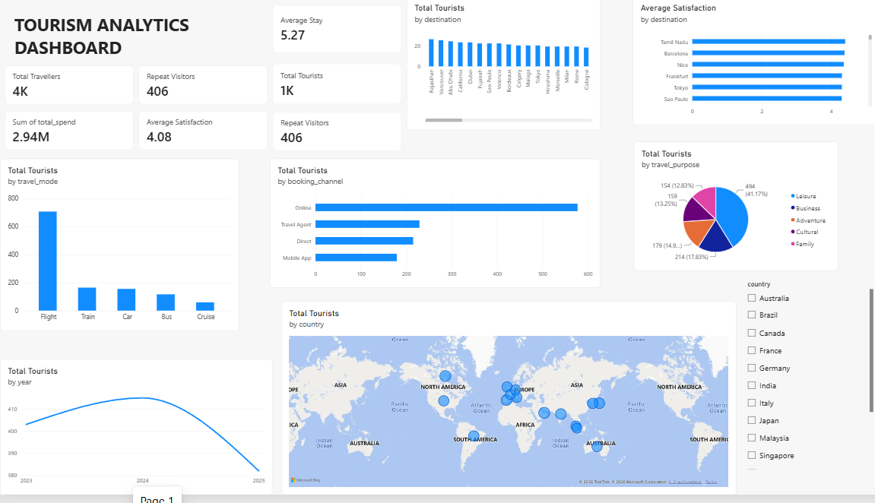

Result:

